Error : 'marked' is not defined no-undef

https://forum.freecodecamp.org/t/marked-is-not-defined/300614/4

Run

$npm i marked

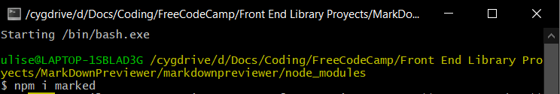

in a terminal from inside the root folder "node_modules".

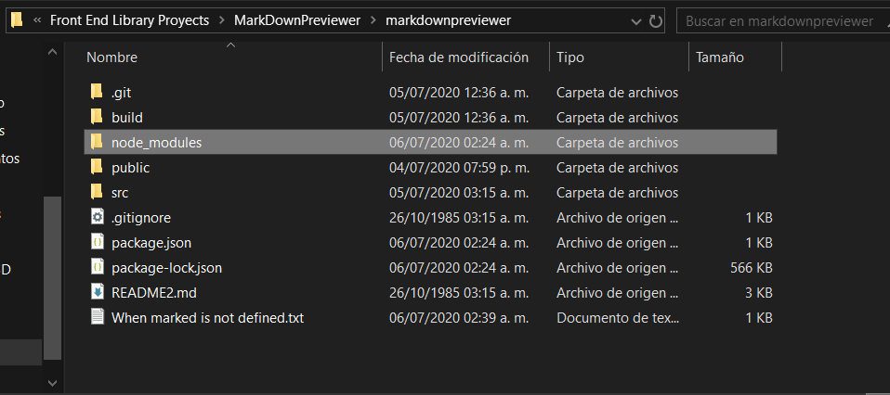

Dentro del archivo donde se solicita "marked"

En este caso:

Import marked inside MarkdownPreviewer.js

import marked from 'marked';

